
SRM Institute of Science and Technology
Mode of Exam
OFFLINE
College of Engineering and Technology
School of Computing
DEPARTMENT OF COMPUTATIONAL INTELLIGENCE
SRM Nagar, Kattankulathur – 603203, Chengalpattu District, Tamilnadu
Academic Year: 2021-22 (EVEN)
Test: CLAT-3 Date: 27.04.2023
Course Code & Title: 18AIC209T Foundation of Metric Spaces Duration: 1 Hour
Year & Sem: II Year & IV Semester Max. Marks: 25 Marks
Course Articulation Matrix: (to be placed)
Course Learning Outcomes (CO): |  |  |  |  |  | At the end of this course, learners will be able to:
CO-1 : |  | Discover whether examples of metric spaces are complete using Cauchy sequences
CO-3 |  | Understand iterative processes on general spaces
CO-3 |  | Can apply principles and algorithms to evaluate models generated from data
Program Learning Outcomes (PLO)
1 | 2 |  | 3 | 4 | 5 |  | 6 | 7 | 8 | 9 | 10 | 11 | 12 | PSO
Engineering Knowledge | Problem Analysis |  | Design & Development | Analysis, Design, Research | Modern Tool Usage |  | Society & Culture | Environment & Sustainability | Ethics | Individual &Team Work | Communication | Project Mgt. & Finance | Life Long Learning | PSO - 1 | PSO - 2 | PSO – 3
3 | 2 |  | 2 | 3 | - |  | - | 1 | - | - | 3 | 2 | 2 | 2 | 2 | 2
3 | 3 |  | 3 | 2 | 3 |  | - | 2 | 1 | - | 3 | 3 | 2 | 2 | 2 | 2
3 | 3 |  | 2 | 3 | 3 |  | 2 | 2 | 2 | 1 | 3 | 2 | - | 2 | 2 | 2

Part - A
(3 x 5 = 15 Marks)
Instructions: Answer any 3
Q. No | Question | Marks | BL | CO | PO | PI Code
1 | Define locally compact spaces. | 5 | 3 | 4 | 1,2 | 2.4.1
2 | Describe limit point compactness. | 5 | 2 | 4 | 1,2 | 1.1.2
3 | Let (X, T) be a second countable topological space, and let B be any basis for T. Prove that B contains a countable subfamily which is a basis for T. | 5 | 2 | 5 | 1,2 | 2.4.1
4 | State the advantages of generalized metric spaces. | 5 | 3 | 5 | 1,2 | 2.3.2
Part – B (1 x 10 = 10 Marks)
Instructions: Answer All
5 | Describe the following:  (i) Countability & separation axioms  (ii) Completely regular and normal spaces | 10 | 2 | 4 | 1,2 | 2.3.2

*Performance Indicators are available separately for Computer Science and Engineering in AICTE examination reforms policy.
Course Outcome (CO) and Bloom’s level (BL) Coverage in Questions

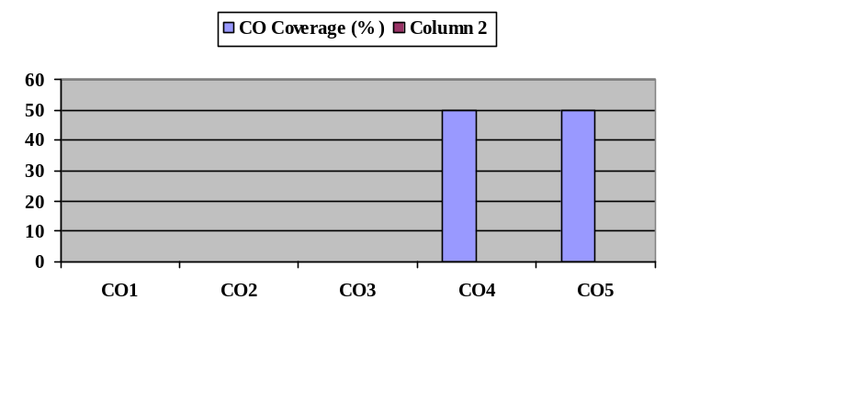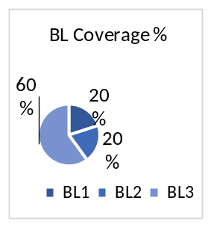
Approved by the Audit Professor/Course Coordinator

